**DEEP2NEURON TECH ACADEMY-INTERNSHIP 2023**

**DAY 4 -22.06.2023**

On the fourth day, there was a meet and we discussed on our progress and intimated our doubts. In this session, I learnt some terminologies and gained some knowledge on code.

**TOPICS COVERED:**

* Loss, Accuracy, Validation loss
* **OVERFITTING :** Loss increases, Accuracy decreases – model didn’t learn.
* **UNDERFITTING :** Loss increases, Accuracy standby – it shouldn’t occur in the model, data is incorrect.
* **DROPOUT** values **-** 0.1, 0.2, 0.3, 0.4, 0.5
* **NEURAL NETWORK:**

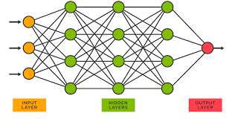

* **EPOCH :** Cycle of neural network that is from input to output.
* **DENSE:** When dense =256 then hidden layer has 256 neurons.
* **BATCH SIZE:** It defines accuracy.
* **STANDARD BATCH SIZES :** 32, 64, 128, 256.

If accuracy not found use 8, 6, 4 batch sizes.

* **LEARNING RATE :** Accuracy changes based on this. LR-0.1, 0.01, 0.001, 0.0001.
* 100 Epochs should be run in all code.
* When epoch increases, confusion matrix changes. It mainly depends upon the model.

**ACTIVITIES:**

Installed Anaconda navigator and worked on confusion matrix.

**TASKS:**

Asked to use the same dataset and run the code in desktop, jupyter notebook or visual studio.

**CONFUSION MATRIX :**

